**Best location for a new Fast-food restaurant in Paris?**

**Manda RAZAFIMANANTSOA**

March 28, 2021

1. **Introduction** 
   1. **Background**

Paris is the capital and most populous city of France with an estimated population of 2 millions as of 2018 (Wikipedia). The capital is divided into twenty “arrondissements municipaux” and is known as one the world’s favorite tourist destination, generating 19,2 billion euros in economic benefits. It welcomes 44,9 million tourists every year including 18,4 million foreigners.

Hotels, restaurants, entertainment and culture are all over the place. This opportunity brings many entrepreneurs to start business every year in Paris.

* 1. **Problem and interest**

A lot of restaurant and particularly fast-food restaurant already exist in Paris. Creating a new fast-food in the capital is a big decision and requires much preparation and a strong business study from the entrepreneur.

The aim of this project is in fact to give a full analyze in order to help the entrepreneur to find the better location to create his fast-food restaurant in Paris. Competitors s

1. **Data acquisition**
   1. **Data source**

Interesting data such as geographical coordinates, name, category, ratings from the clients and even the photo of all existing restaurants in Paris are available from Foursquare API.

This API is used in this project to explore Paris and locate all existing Fast-food restaurant in the city. This will help me a lot to have an overview of geographic repartition of restaurant in Paris and why not compare the data between the twenty “arrondissement”.

As statically known, young people are more interested by Fast-food. A recently publication (in French) below can highlights this fact. 84% of 18-24 like to eat in Fast Food restaurant, whereas only 51% of 50-64 years old go to this category of restauration. The interests are therefore not the same depending on the age of the population.

[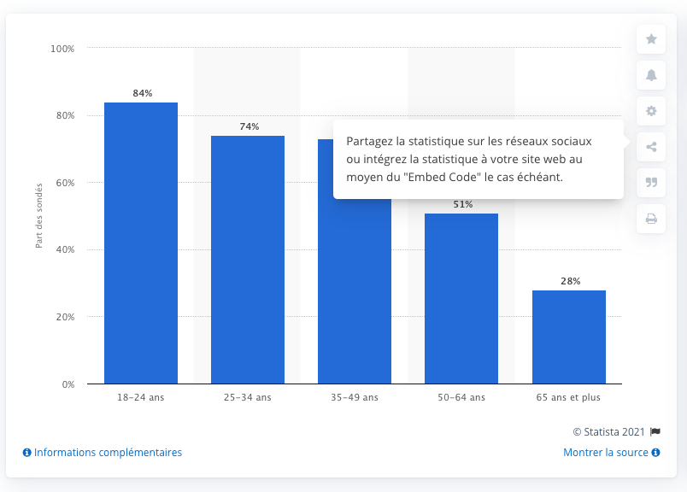](https://fr.statista.com/statistiques/1027763/part-francais-aiment-manger-fast-food-selon-lage/#)

*https://fr.statista.com/statistiques/1027763/part-francais-aiment-manger-fast-food-selon-lage/*

Consequently, in addition to the information from Foursquare, I decided to add further data to my analytical approach. The idea is to get the percentage of “young people” (18-45) in each borough of Paris.

This data can be found in the official French data website data.gouv.fr, the csv file is downloadable here [Age per borough in Paris](https://static.data.gouv.fr/resources/population-municipale-t-popmun-com/20201002-105559/t-popmun-2017-com.csv). This document sets out population number for each sexe in each borough in Paris.



A cleaning task of this SQL format is needed to fill my needs: I have to do some calculation to get the total percentage of each age (column: *popmun_age*) for each borough (*com_code*) ignoring the sexe of the population.